How to use jupyter notebook(IDE)

Open cmd promt:

Enter cmd: **ipython notebook** or cmd:**jupyter notebook**

New browser will be opened as shown below(notebook dashboard)

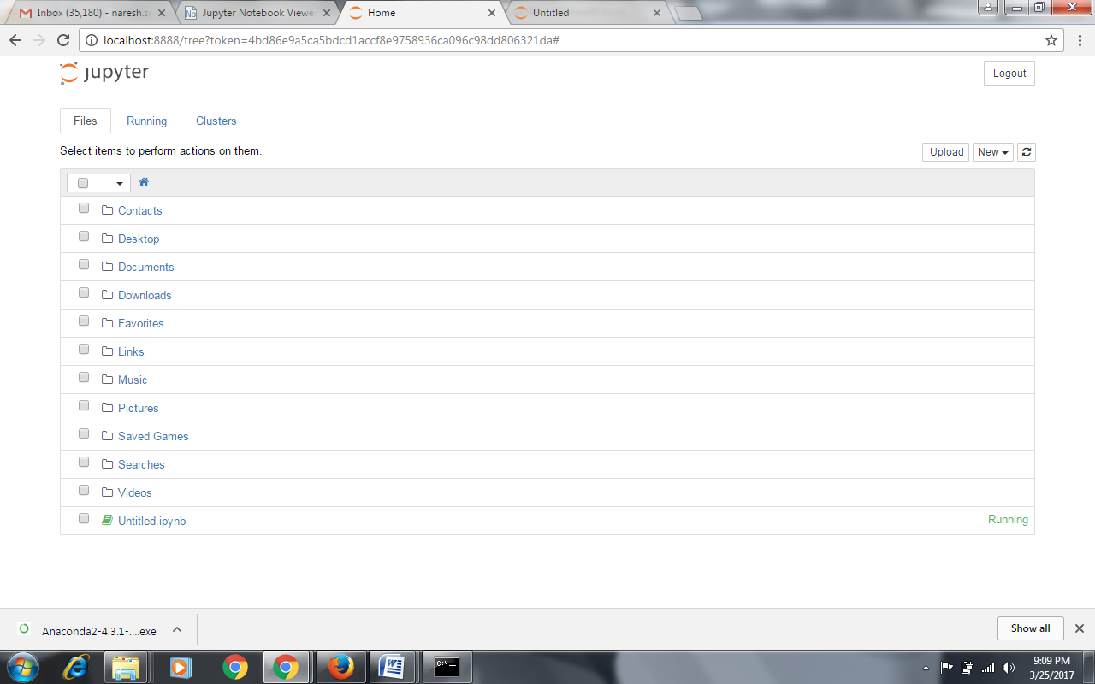

**Go to new->python 2:**

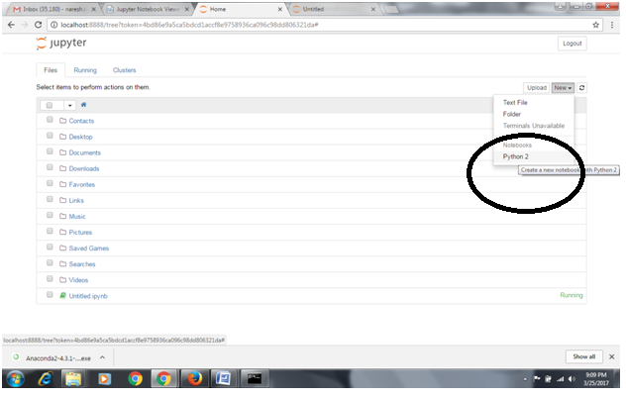

**New notebook will be opened as below:**



**Enter any command in the in[] cell as highlighted.**

**Eg:** **print "Hello, Python!"**

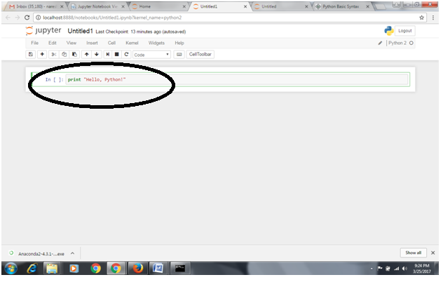

**Click on button which is highlighted to run the command:**

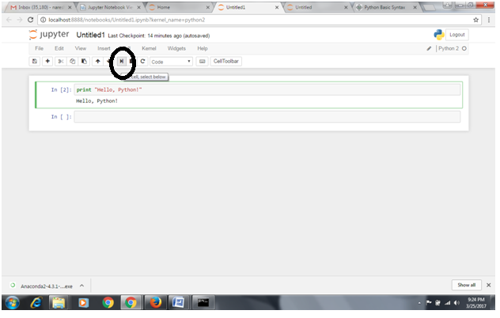

**Note: notebook will be auto saved continouosly.**

**Click on + button to add new input cell**